**TMS 762: PHYSICAL PROPERTIES OF FIBER FORMING POLYMERS**

**TEST 2**

**DATE: March 22, 2023**

**STUDENT NAME:**

**INSTRUCTIONS:**

* **Submit the Test by 11:59 pm on March 29, 2022 via Moodle.**
* Write as legibly as possible or type answers. When giving short answers, write down your thoughts clearly and concisely. Bullet points are acceptable when given in proper context. I do review outlines and markings in addition to your short answer statements.
* Open notes, the internet, and calculator are allowed for this test. Peer assistance is not allowed. Ask the instructor if you have questions.
* Submit answer pages as one-single PDF document and submit via Moodle online.
* Upload Genius Scan to your cellular phone app to convert handwritten pages into one PDF document.

https://play.google.com/store/apps/details?id=com.thegrizzlylabs.geniusscan.free&hl=en

**MY PACK PLEDGE**

I have neither given nor received unauthorized aid on this test.

__________________________           ________________________

**Signature                                                   Date**

BLANK

PAGE

**1. The dyeability of polyester fiber is related to its chemical structure, which results from the reaction of terephthalic acid and an alkane diol. Polyethylene terephthalate (PET), polytrimethylene terephthalate (PTT), and polybutylene terephthalate (PBT) are commonly used polyester fibers. The thermal properties (which were experimentally determined) and the crystal structures of these polymers are also given. Use the figures below to answer the following questions (a-f). Explain your answers to the following questions. Show all of your work and formulas.**

1. **Based on its chemical structure, calculate the theoretical heat of fusion (i.e. enthalpy of melting) in J/mol for PET.**

**_____________/15 Pts**

1. **Based on its chemical structure, calculate the theoretical heat of fusion (i.e. enthalpy of melting) in J/mol for PTT.**

**_____________/15 Pts**

1. **Compare theoretical values of heat of fusion for PET versus that of PTT based on its chemical structure and crystal structure. Include a discussion on the thermodynamics of melting for both polymers.**

**_____________/20 Pts**

1. **Compares values for the ΔH(Tg) for PET and PTT.**

**_____________/15 Pts**

1. **PTT is known to dye more readily than PET. Describe your prediction of how either the ΔH(at Dyeing Temp) OR ΔS(at Dyeing Temp) for PET and PTT would compare. How could either ΔH(at Dyeing Temp) OR ΔS(at Dyeing Temp) be used to explain differences in dyeability for PET and PTT for comparison? Reference related graphs and thermodynamic parameters.**

**_____________/15 Pts**

1. **Solubility parameters have characterized polymer dissolution, polymer shrinkage in solvents and even polymer crystallization in solvents. Describe how solubility parameters may help to characterize the differences in dyeability for PET, PTT, PBT, and other polyesters as the alkane chain increases in mass. Give an example of the type of data collected and how it could be used to observe trends in dyeability in respect to dye uptake, color fastness, AND/OR dye temperature. Include relevant theories/models for solubility in your answer.**

**_____________/20 Pts**

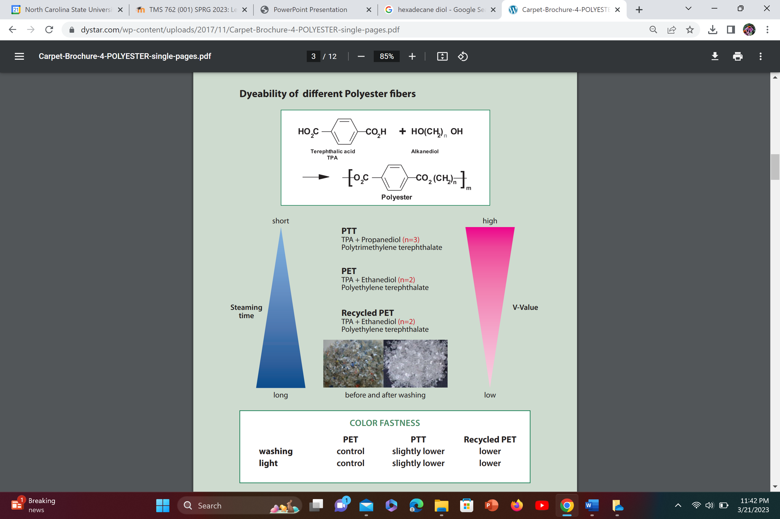

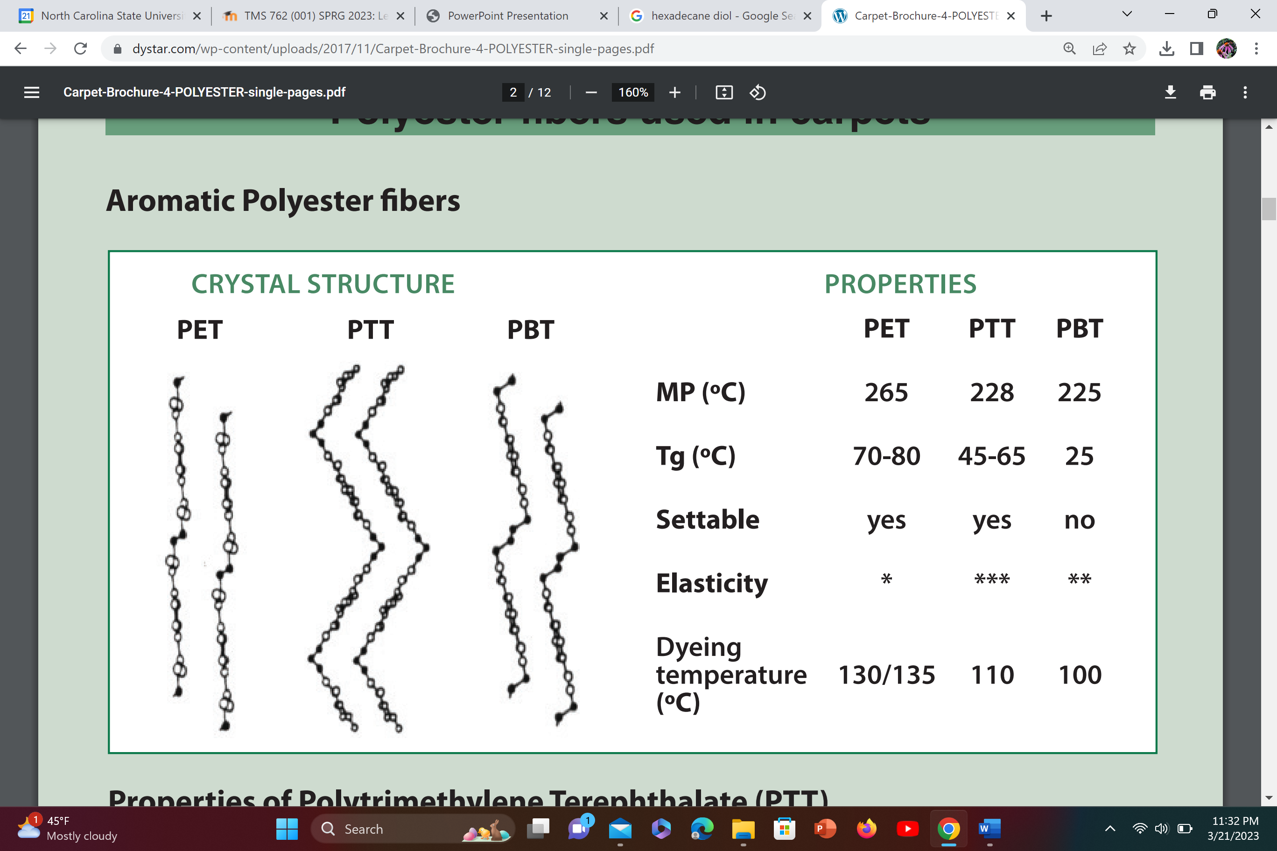

**MP = Melting point = Tm (peak temperature of melting)**